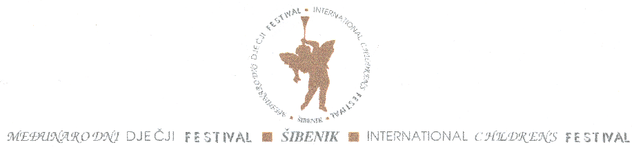
Hrvatsko narodno kazalište u Šibeniku
Međunarodni dječji festival Šibenik – Hrvatska
Kralja Zvonimira 122000
Šibenik - Hrvatska
To whom it may concern,
I would like to invite you to participate in 57. International Children Festival that takes place in Šibenik Croatia from 17th June till 1st July 2017.

The first festival was held in 1958, the result of the initiative and efforts of several children arts enthusiast. During the years Festival has turned into a big complex multidisciplinary multimedial cultural event, which not only displays but invites participation actively. It is a review of the best works for children as well as of the best works by children.
The basic cultural and pedagogical justification of the festival is that it promotes aesthetical education of children and young adults, and develops all artistic forms of children creativity. The festival not only initiates but also stimulates many ideas in art forms for children and by children: dramatic and music arts, puppetry, film, literature and visual art. The festival has the full support of UNICEF and UNESCO and continuing patronage of the Croatian President.

As the Manager of the Festival, I initially screen for potential shows that would be of interest for participation in our Festival. However, the last word regarding the selection of the shows/performances is on The Artistic Board of the Festival.
Therefore, I would like to invite you to submit you application which consist of:
1. filling out the application form that I`m sending you in attachment
2. technical rider
3. video recording of a FULL performance.The full performance can be submitted either as a DVD which you need to send to address indicated ( HNK u Šibeniku, Internacional Children Festival, Kralja Zvonimira 1, 22 000 Šibenik, Republic of Croatia) or a link to internet content.
The deadline for submission is the 9th of December 2016. The final selection of the shows will be announced beginning of January 2017.

Hopefully if you decide to participate to our Festival, we will stay in touch. Please do not hesitate to contact me in case you need more detailed information or visit the official website of the Festival ( http://mdf-sibenik.com/?lang=en )

Best Regards,
Ivana Badzim,
Festival Manager
ivanabadzim@gmail.com

